WEEK 8 : GIT

S.NO :1

GIT SETUP AND OUTPUT:

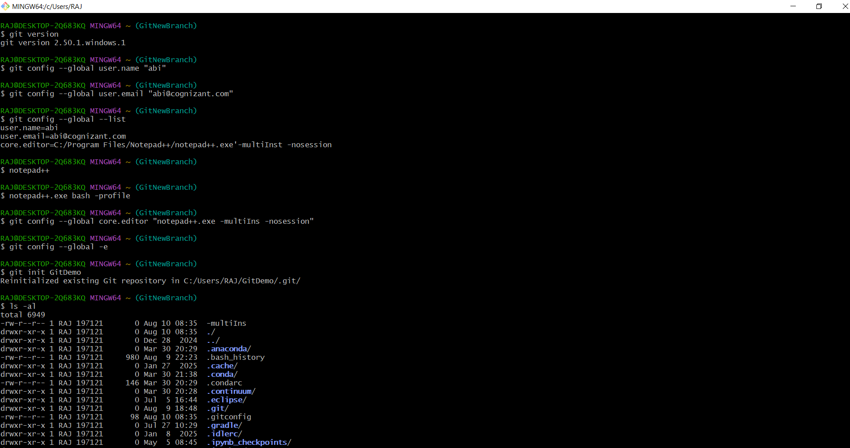

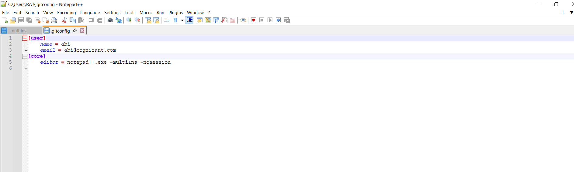

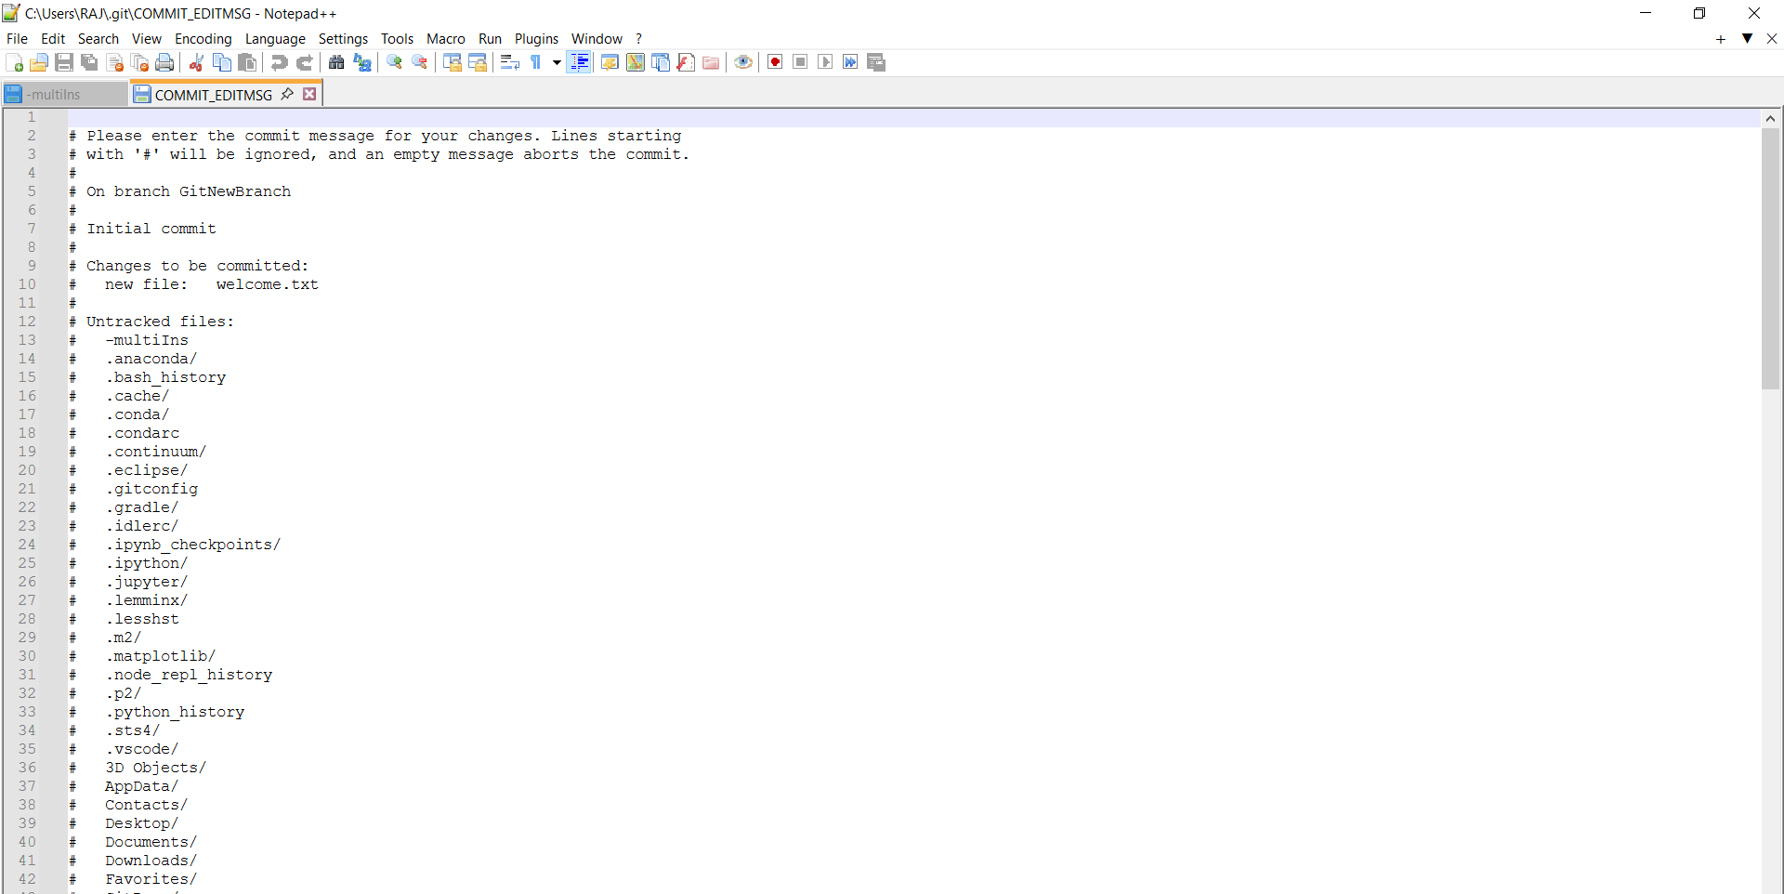

S.NO:2

CREATE A .LOG FILE AND LOG FOLDER

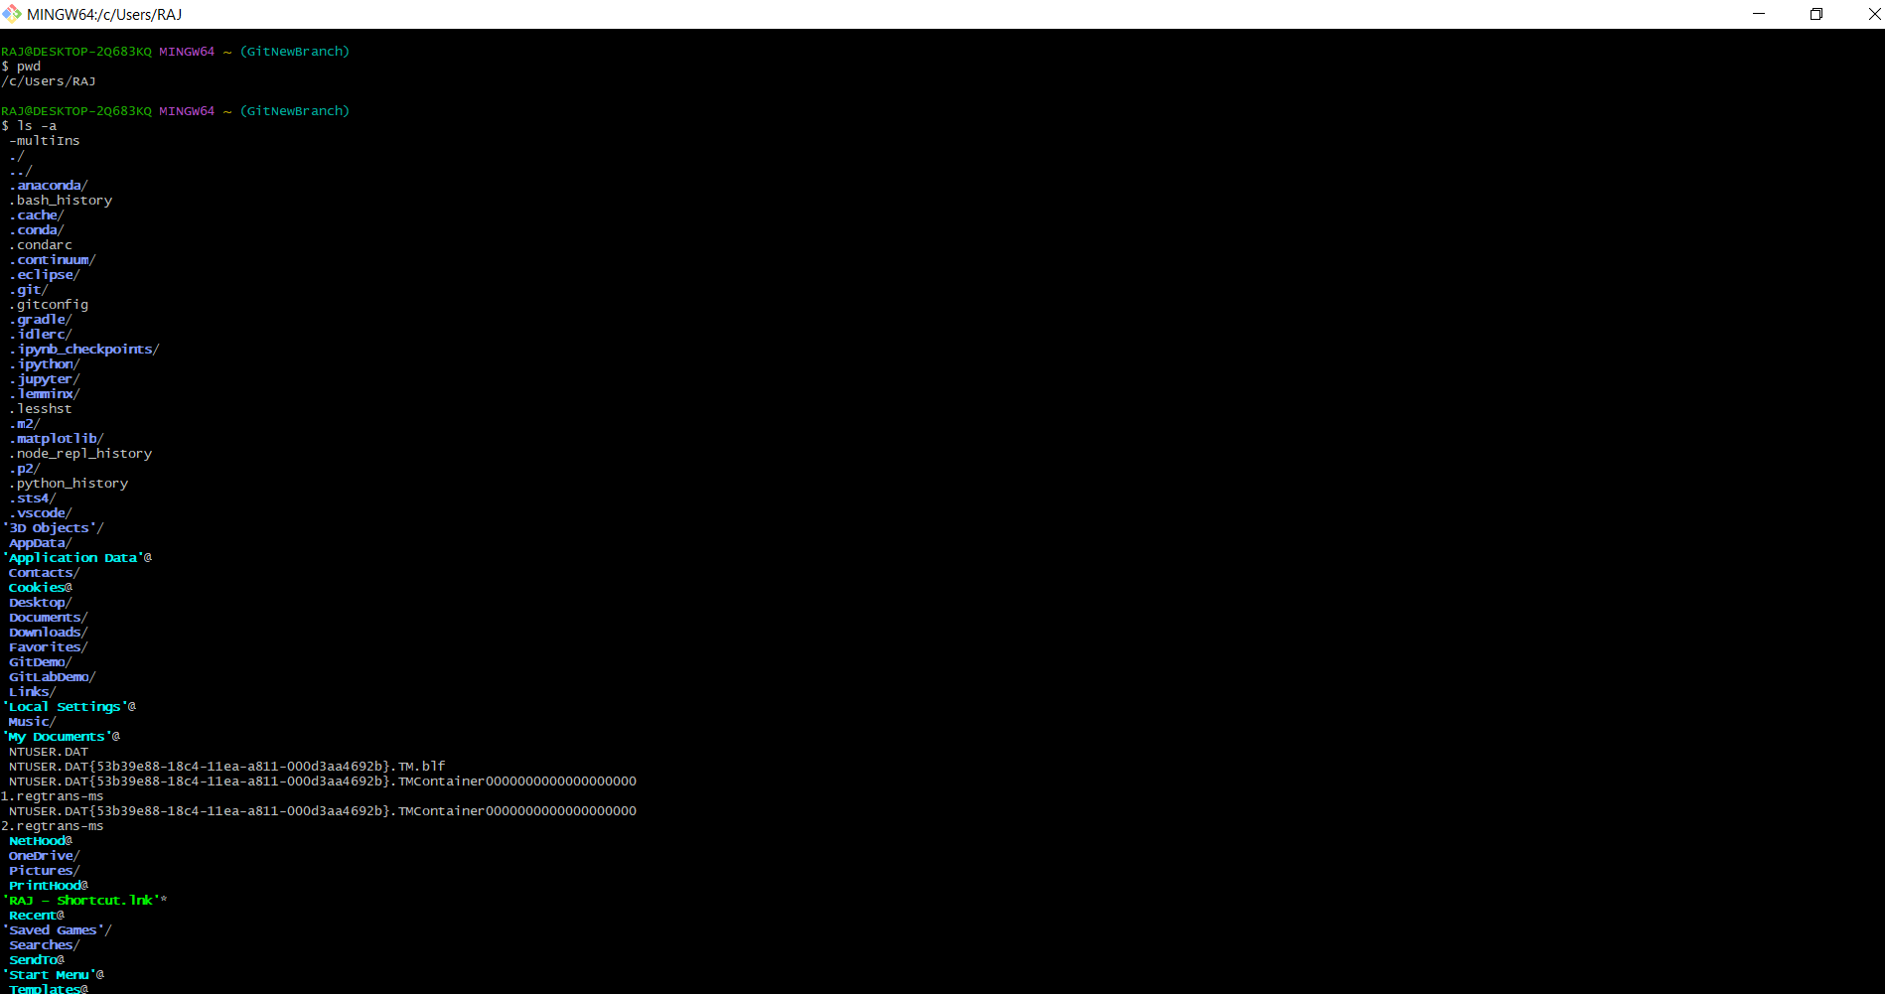

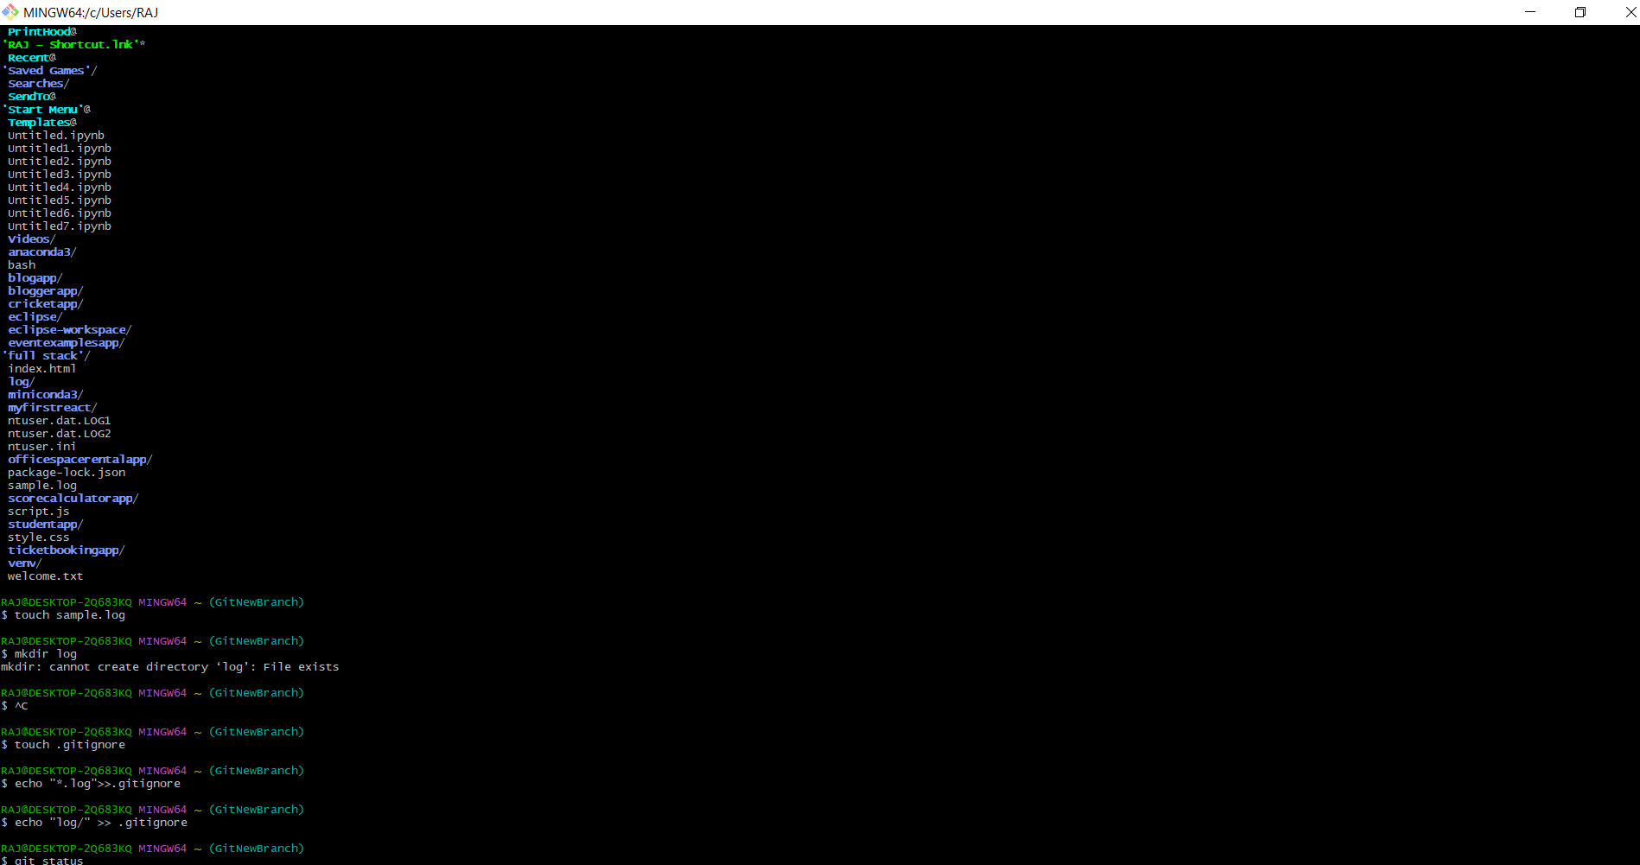

S.NO : 3 BRANCHING AND MERGING

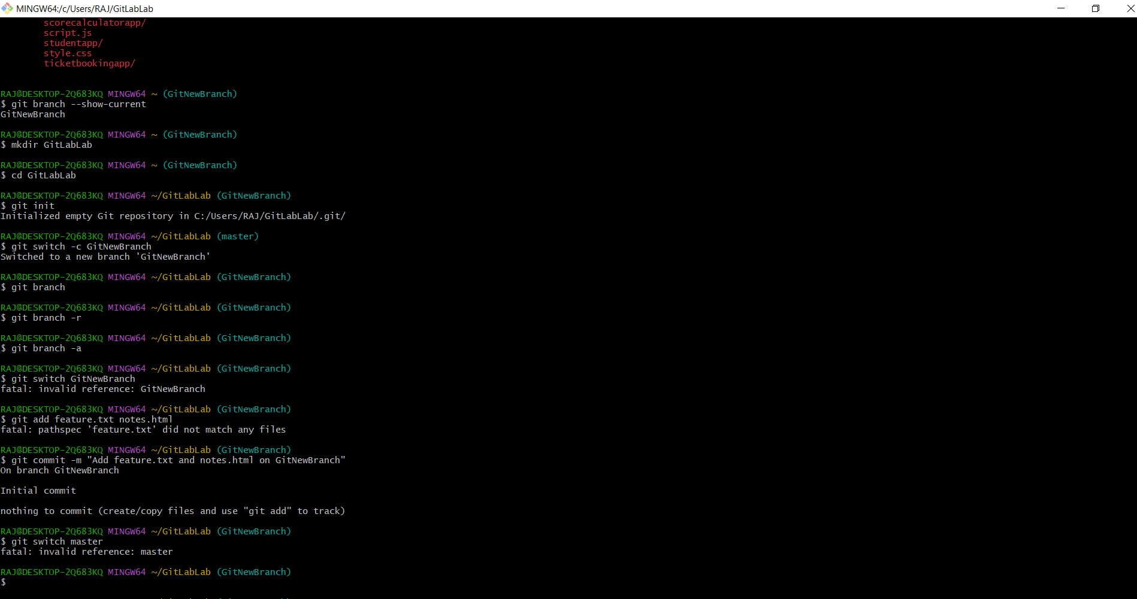

S.NO:4 GIT WORK

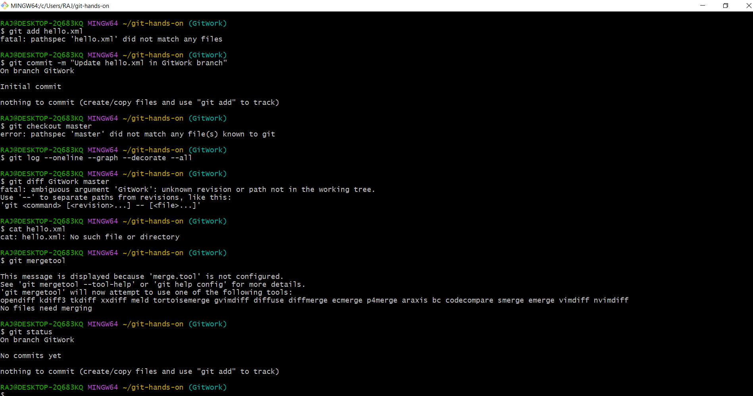

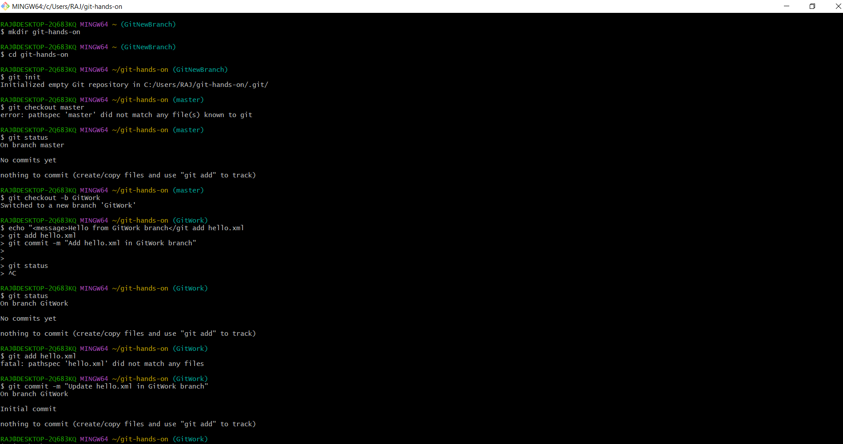

S.NO:5 VERIFY IF MASTER IN CLEAN STATE

